Principal: Mrs Ríoghnach Hall
Address: 2 Servia Street, Belfast, BT12 4EJ
Phone: 02890246675
Email: stpetersnursery@hotmail.com

Safeguarding and Child Protection:
A Guide for Parents
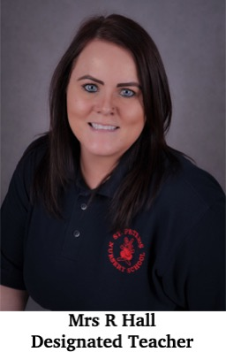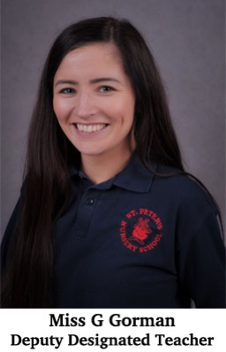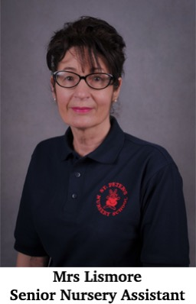
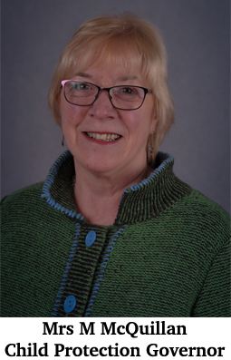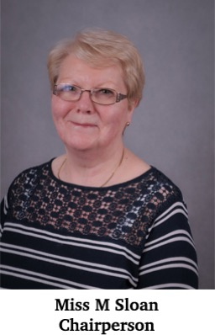

Dear Parent

This booklet has been written to raise awareness of child abuse and neglect and also to outline to you the steps that St Peter’s Nursery School will take to ensure that your child can enjoy the safe, secure and happy childhood environment to which they are entitled.

This means that as child educators and carers Nursery staff must at all times continue to take their responsibilities seriously in order to ensure that the rights of the children in this school are protected.

I hope that these guidelines will give you information on how you as a parent can deal with concerns about a child or indeed a member of staff. I hope it also reassures you about the seriousness with which the staff at St Peter’s Nursery take our roles and responsibilities in protecting the children in our care. A copy of the full policy can be given upon request.

Mrs Ríoghnach Hall
Principal

The Safeguarding Team

Board of Governors Chairperson: Miss Margaret Sloan
Designated Governors for Child Protection: Mrs Margaret Mc Quillan
Principal: Mrs Ríoghnach Hall
Designated Teacher: Mrs Ríoghnach Hall
Deputy Designated Teacher: Miss Geraldine Gorman
Deputy Designated Officer in
absence of DT / DDT: Mrs Angela Lismore

Child Protection Statement: The governors and Staff of this school have a Duty of Care to all the children enrolled in St Peter’s Nursery School. Our aim is to protect them from HARM and accordingly will do whatever is reasonable to safeguard and protect them. Child Protection Procedures have been established to promote the welfare and safety of all the children.

For advice or support you can contact:
Mrs Ríoghnach Hall Tel:02890246675
Designated Child Protection Teacher
Duty Social Worker
Gateway Centre – Tel:02890507000/02890565444

Miss Margaret Sloan
Chairperson of the Board of Governors
Tel:02890246675

Duty Social Worker
Beech Hall
Tel:02890636262

02890636262
Child Protection Officer at BELB
Therese Moran / Brenda Walker /Patricia O’Hare
Tel:028905985590

Miss Geraldine Gorman
Tel:02890246675
Deputy Designated Child Protection Teacher
Child Protection Offer at CCMS
Tel:90327875

Child Protection

What you as a parent should do:
I have a concern about my/a child’s safety

I can talk to the class teacher
If I am still concerned, I can talk to the Designated Teacher for Child Protection
If I am still concerned I can talk or write to the Chairperson of the Board of Governors – Miss Margaret Sloan
c/o St Peter’s Nursery School
Belfast BT12 4EJ
Email stpetersnursery@hotmail.com

If I am still concerned I can contact the NI Public Services Ombudsman –
Tel: 0800 343 424

At anytime, I can write or talk to:
a Social Worker at Belfast Gateway Team Tel:02890 507000
or the PSNI Central Referral Unit Tel: 028 9025 9299

REMEMBER CHILD PROTECTION IS EVERYBODY’S BUSINESS

What is Child Abuse?
- A child is a person under the age of 18 years as defined in the Children Order.
- Child Abuse occurs when ‘a child is neglected, harmed or not provided with
proper care. Children may be abused in many settings, in a family, in an institutional or community setting, by those known to them, or more rarely, a stranger.’ (ACPC, 2005)
- Child abuse occurs in families from all social classes and cultures and it also occurs in agencies and organisations. Abusers come from all walks of life and all occupations and professions. Children may be abused by a parent, a sibling or other relative, a carer, an acquaintance or a stranger who may be an adult or young person. The abuse may be the result of a deliberate act or failure on the part of a parent or carer to act or provide proper care.

Definitions of Abuse, Signs and Symptoms
- Physical Abuse: deliberately physically hurting a child. It might take a variety of different forms, including hitting, biting, pinching, shaking, throwing, poisoning, burning or scalding, drowning or suffocating a child. (ACPC, 2005).

Possible signs or symptoms of physical abuse include:
- Unexplained bruises (in places difficult to mark)
- Human bite marks, welts or bald spots, unexplained lacerations, fractions or abrasions
- Untreated injuries
- Self-destructive tendencies
- Chronic runaway
- Fear of going home

Emotional Abuse: is the persistent emotional maltreatment of a child. It is also sometimes called psychological abuse and it can have severe and persistent adverse effects on a child’s emotional development. Emotional abuse may involve deliberately telling a child that they are worthless, or unloved and inadequate. It may include not giving a child opportunities to express their views, deliberately silencing them, or ‘making fun’ of what they say or how they communicate. Emotional abuse may involve bullying – including online bullying through social networks, online games or mobile phones – by a child’s peers. (ACPC, 2005).

Possible signs or symptoms of emotional abuse include:
- Bullying of others
- Change in personality from outgoing to withdrawn
- Difficulty in forming/maintaining relationships with others
- Depression
- Signs of mutilation
- Attention seeking
- Chronic runaway
- Wetting and soiling
- Sudden speech disorders
- Low self esteem
- Sexual Abuse: occurs when others use and exploit children sexually for their own gratification or gain or the gratification of others. Sexual abuse may involve physical contact, including assault by penetration (for example, rape, or oral sex) or non-penetrative acts such as masturbation, kissing, rubbing and touching outside clothing. It may include non-contact activities, such as involving children in the production of sexual images, forcing children to look at sexual images or watch sexual activities, encouraging children to behave in sexually inappropriate ways or grooming a child in preparation for abuse (including via e-technology). Sexual abuse is not solely perpetrated by adult males. Women can commit acts of sexual abuse, as can other children. (ACPC, 2005)
Possible signs or symptoms of sexual abuse include:
- Bruised or sore genitals
- Genital infection
- Difficulty in walking or sitting
- Inappropriate sexualised language or behaviour
- Low self-esteem
- Chronic depression
- Substance abuse
- Personality changes
- Fear of going home

- Neglect: is the failure to provide for a child’s basic needs, whether it be adequate food, clothing, hygiene, supervision or shelter that is likely to result in the serious impairment of a child’s health or development. Children who are neglected often also suffer from other types of abuse. (ACPC, 2005).

Possible signs or symptoms of neglect include:
- Poor hygiene
- Constant hunger/cramming food
- Inadequate/inappropriate clothing
- Constant tiredness
- Exposed to danger/lack of adequate supervision
- Untreated illness
- Lack of peer relationships
- Compulsive stealing/begging

- Exploitation: Child sexual exploitation is a form of child sexual abuse. It occurs where an individual or group takes advantage of an imbalance of power to coerce, manipulate or deceive a child or young person under the age of 18 into sexual activity (a) in exchange for something the victim needs or wants, and/ or (b) for the financial advantage or increased status of the perpetrator or facilitator. The victim may have been sexually exploited even if the sexual activity appears consensual. Child sexual exploitation does not always involve physical contact; it can also occur through the use of technology.

A child may suffer or be at risk from one or more types of abuse and abuse may take place on a single occasion or may occur repeatedly over time.
Our daily contact with the children means all staff, teaching, non-teaching and volunteers are well placed to observe outward symptoms and changes in appearance, behaviour, learning patterns or development.
Staff must be aware that any single or combination of the above may be accompanied by or solely manifested in a marked deterioration in performance and/or increased absenteeism. Equally, we must remember that alternative medical, psychological or social explanations may exist for the signs and symptoms used. The staff will acknowledge that the signs listed above give rise to concern but are not in themselves proof that abuse occurred. Rather we will be alert to such signs if they appear and will report such concerns to the Designated Teacher. Staff will be aware of the necessity of vigilance regarding safeguarding the children in our care. Our observations, if they instigate an investigation regarding suspected abuse, may result in action by a statutory investigating agency.

Specific Types of Abuse

Grooming: Where the perpetrator gains the trust of a young person or their family, through be-friending or making an emotional connection, in order to exploit and abuse them. It may be sexual or other forms of abuse in nature or be a pre-cursor to this. Staff at St Peter’s Nursery School will ensure that contact with the pupils in the school is limited only to those who have undergone the appropriate vetting procedures.

Domestic and Sexual Abuse/Violence: Exposure to domestic violence can have a significant impact on children and their emotional development and wellbeing. The DT and DDT of St Peter’s Nursery School will have training in Domestic Violence. Any suspected or disclosed incidents of domestic violence will be reported to the appropriate authorities, in line with the school safeguarding policy and procedures.

Female Genital Mutilation: Staff of St Peter’s Nursery School are familiar with the contents of the 2003 Female Genital Mutilation Act. Female Genital Mutilation (FGM) includes procedures which intentionally alter or injure the female genital organs for non-medical reasons. FGM is carried out in a number of countries worldwide. In the UK, FGM is illegal. Children may be subjected to FGM from around the age of five years onwards. It is possible that children of Nursery age could be at risk of FGM, as could other siblings within a family group.

Risk factors associated with FGM include:
- Coming from a community known to practise FGM
- An extended family member has undergone an FGM procedure

Warning signs that the child may be about to undergo the procedure include:
- Family plans an extended trip to country of origin
- Female relative comes to visit
- Child talks about a ‘special event’ which is about to take place

FGM is a safeguarding issue. Should a member of staff or indeed a parent of St Peter’s Nursery School be concerned that a child is at risk of FGM then they have a duty to inform the DT or DDT who will follow safeguarding procedures.

Forced marriage: Whilst this is unlikely to be an issue for our pupils directly, staff will be aware of the potential for this to occur with older siblings within families. Should staff of St Peter’s Nursery School become aware that a pupil’s family member (child or young person) is at risk from this, this is treated as a safeguarding/child protection matter and reported in line with our Safeguarding policy.

Children who display harmful sexualised behaviours: Learning about sex and sexual behaviour is a normal part of a child’s development, however there are some sexualised behaviours which would not be acceptable for a child to display in the school environment and indeed would give cause for concern should an adult observe behaviour which is not age appropriate.

DENI circular 2016/05 highlights problematic sexual behaviour as including some of the following characteristics:

- Not age appropriate
- One off incident of low key touching over clothes
- Result of peer pressure
- Spontaneous rather than planned
- Lacking in other balancing factors e.g. no intent to cause harm, level of understanding, acceptance of responsibility
- Targeting other children, to irritate and make feel uncomfortable. Often the children are not scared and can feel free to tell someone
- Concerning to parents / carers
- Sometimes involving substances which disinhibit behaviours

Problematic sexualised behaviours will require some level of intervention, as appropriate, generally at school level. More serious incidents may be considered to be classed as Harmful Sexualised Behaviour and could include:

- Lacks the consent of the victim
- When the perpetrator uses threats or violence (verbal, physical or emotional) to coerce or intimidate the victim
- Uses age inappropriate sexually explicit words and phrases
- Involves inappropriate touching
- Involves sexual behaviour between children – it is also considered harmful if one of the children is much older – particularly if there is more than two years’ difference in age or if one of the children is pre-pubescent and the other is not
- Involves a younger child abusing an older child, particularly if they have power over them – for example, if the older child is disabled

Harmful sexualised behaviour will always require intervention. Should a member of staff of St Peter’s Nursery School suspect, observe or receive a disclosure of Harmful Sexualised Behaviour then they will immediately follow the schools procedures on reporting a safeguarding concern.

Where the Designated Teacher or Deputy Designated Teacher are made aware of any concerns relating to sexualised behaviour, then they will deal with this as a Child Protection concern and follow the school safeguarding procedures, including advice contained in DENI circular 2016/05. The Principal would be kept informed of any such concerns and be involved in deciding on the best course of action to take.
The CPSSS will be contacted, if necessary, for additional clarification and support on specific issues and scenarios.
Internet abuse, cyber bullying and online safety: St Peter’s Nursery School shall ensure that pupils are not permitted to access any inappropriate material online and at all times promote online safety. Use of Ipads in school by children is restricted using parental controls to ‘lock in’ to an app chosen by staff members. Occasionally, you tube/google may be used when researching something or accessing music. This is only permitted by a staff member working with a child/group and who controls the access to suitable content.

Allegations of cyber bullying of a pupil or staff shall be dealt with in accordance with our anti-bullying and safeguarding policies and procedures.

Bullying: Bullying is a highly distressing and damaging form of abuse and is not tolerated in St Peter’s Nursery School.

Our anti- bullying policy is informed by the ‘Addressing Bullying in Schools Act’ (2016) and is set out in a separate policy. It acknowledges that to allow or condone bullying may lead to consideration under safeguarding procedures.
Staff are vigilant at all times to the possibility of bullying occurring, and will take immediate steps to stop it happening to protect and reassure the victim
and to discipline the bully. Parents of both the bully and the victim will be personally contacted when bullying has been identified.

Any complaints by a parent that their child is, or may be, being bullied will be fully investigated by the DT for Safeguarding and team action will be taken to protect the victim. This will usually include ensuring that St Peter’s Nursery child or a group of small children befriends and supports the child being bullied during the school day. A parent making a complaint about bullying will have a personal response from the DT within one week of making the complaint, indicating the investigation which has been carried out and the action taken. A record of all incidents of bullying/alleged bullying will be kept in the School’s Anti- Bullying Register.

The sanctions taken against a pupil who bullies will depend on the seriousness of the case but will include the loss of privileges in the school. His/her behaviour will be carefully monitored until staff are satisfied that the problem has stopped. If a pupil’s bullying behaviour persists, the second stage will be to instigate the safeguarding procedures.
Bullying Procedure:
- Children will always be supervised and observed closely.
- All incidences worthy of note will be recorded. Incidences which involve: biting, spitting, pulling hair, kicking, fighting or injuring others will be reported to parents who will be asked to sign a pro-forma to confirm that incident has been reported.
- In the instance of a child bullying another, the teacher will approach and speak informally with the parents of the offender in an effort to find a cause for the child’s behaviour.
- When continual observation of bullying has been noted the offending child’s parents will be asked to meet the teacher formally to discuss what is happening and try to find a solution.

If a parent complains that their child is being bullied:
- Parent will be acknowledged and thanked
- Parent will be informed of procedure which will be followed
- Observations will be kept on child by all members of staff for a full week
- Parent will be invited back to meet teacher to discuss findings
- If a matter isn’t resolved an action plan should be drawn up.

Parental Responsibility: It is important that the Principal (Mrs Ríoghnach Hall) is informed if any member of your child’s family does NOT have access to collect your child.

Arrivals and Collections: Please note that a responsible adult must always bring your child to and from school. It is illegal for anyone under the age of 16 to bring or collect your child from school. Each family will be given a codeword. Should someone other than mum or dad be collecting your child from school please make them aware of the codeword as they will be asked for this before we can allow your child to leave the premises.

We would like to assure parents that any information given about or recorded on your child is treated in a strictly confidential manner. Staff are not permitted to discuss information about any child with anyone other than the designated officers.

